How to push images from ubuntu ec2 to docker hub private repo,
Login our docker hub use this command,
Sudo docker login
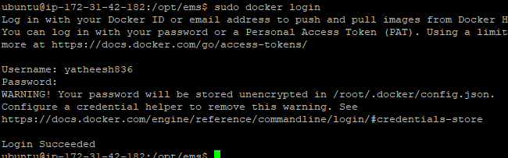

Give tages name or just tags,
sudo docker tag idintity-image:latest yatheesh836/ems-aws-images:idintity-image-latest
sudo docker tag ui-image:latest yatheesh836/ems-aws-images:ui-image-latest
sudo docker tag employee-image:latest yatheesh836/ems-aws-images:employee-image-latest
now push our docker images from ec2 to docker hub,
sudo docker push yatheesh836/ems-aws-images:idintity-image-latest
sudo docker push yatheesh836/ems-aws-images:ui-image-latest
sudo docker push yatheesh836/ems-aws-images:employee-image-latest

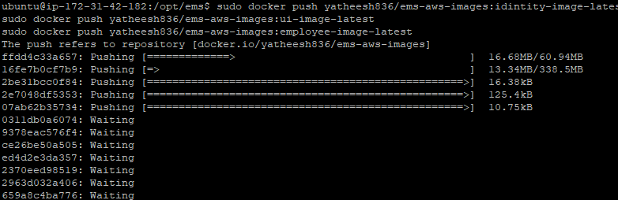

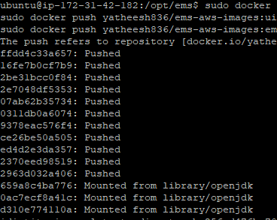
This was my docker hub account now check repo in saide docker images,
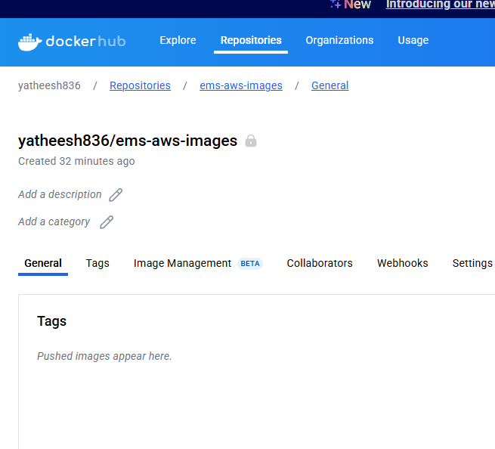

You can see after refresh,
